**Experiment No. 1**

**Aim:** Data Wrangling: I Perform the following operations using Python on any open source dataset (e.g., data.csv)

1. Import all the required Python Libraries.

2. Locate an open source data from the web (e.g., https://www.kaggle.com). Provide a clear description of the data and its source (i.e., URL of the web site).

3. Load the Dataset into pandas dataframe.

4. Data Preprocessing: check for missing values in the data using pandas isnull(), describe() function to get some initial statistics. Provide variable descriptions. Types of variables etc. Check the dimensions of the data frame.

5. Data Formatting and Data Normalization: Summarize the types of variables by checking the data types (i.e., character, numeric, integer, factor, and logical) of the variables in the data set. If variables are not in the correct data type, apply proper type conversions.

6. Turn categorical variables into quantitative variables in Python. In addition to the codes and outputs, explain every operation that you do in the above steps and explain everything that you do to import/read/scrape the data set.

**Data Wrangling in Python**

Data Wrangling is the process of gathering, collecting, and transforming Raw data into another format for better understanding, decision-making, accessing, and analysis in less time. Data Wrangling is also known as Data Munging.

**Importance Of Data Wrangling**

Data Wrangling is a very important step. The below example will explain its importance as :

Books selling Website want to show top-selling books of different domains, according to user preference. For example, a new user search for motivational books, then they want to show those motivational books which sell the most or having a high rating, etc.

But on their website, there are plenty of raw data from different users. Here the concept of Data Munging or Data Wrangling is used. As we know Data is not Wrangled by System. This process is done by Data Scientists. So, the data Scientist will wrangle data in such a way that they will sort that motivational books that are sold more or have high ratings or user buy this book with these package of Books, etc. On the basis of that, the new user will make choice. This will explain the importance of Data wrangling.

**Data Wrangling in Python** Data Wrangling is a crucial topic for Data Science and Data Analysis. Pandas Framework of Python is used for Data Wrangling. Pandas is an open-source library specifically developed for Data Analysis and Data Science. The process like data sorting or filtration, Data grouping, etc.

Data wrangling in python deals with the below functionalities:

1. **Data exploration:**In this process, the data is studied, analyzed and understood by visualizing representations of data.
2. **Dealing with missing values:**Most of the datasets having a vast amount of data contain missing values of *NaN, they are needed to be taken*careof by replacing them with mean, mode, the most frequent value of the column or simply by dropping the row having a *NaN*value.
3. **Reshaping data:**In this process, data is manipulated according to the requirements, where new data can be added or pre-existing data can be modified.
4. **Filtering data:**Some times datasets are comprised of unwanted rows or columns which are required to be removed or filtered
5. **Other:** After dealing with the raw dataset with the above functionalities we get an efficient dataset as per our requirements and then it can be used for a required purpose like data analyzing, machine learning, data visualization, model training etc.

**Below is an example which implements the above functionalities on a raw dataset:**

* **Data exploration**, here we assign the data, and then we visualize the data in a tabular format.

|  |
| --- |
| Python3  # Import pandas package  import pandas as pd    # Assign data  data = {'Name': ['Jai', 'Princi', 'Gaurav',                   'Anuj', 'Ravi', 'Natasha', 'Riya'],          'Age': [17, 17, 18, 17, 18, 17, 17],          'Gender': ['M', 'F', 'M', 'M', 'M', 'F', 'F'],          'Marks': [90, 76, 'NaN', 74, 65, 'NaN', 71]}    # Convert into DataFrame  df = pd.DataFrame(data)    # Display data  df |

**Output:**

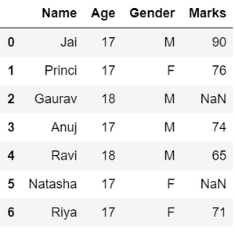

* **Dealing with missing values**, as we can see from the previous output, there are *NaN*values present in the *MARKS*column which are going to be taken care of by replacing them with the column mean.

|  |
| --- |
| Python3  # Compute average  c = avg = 0  for ele in df['Marks']:      if str(ele).isnumeric():          c += 1          avg += ele  avg /= c    # Replace missing values  df = df.replace(to_replace="NaN",                  value=avg)    # Display data  df |

**Output:**

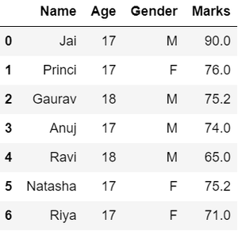

* **Reshaping data**, in the *GENDER*column, we can reshape the data by categorizing them into different numbers.

|  |
| --- |
| Python3  # Categorize gender  df['Gender'] = df['Gender'].map({'M': 0,                                   'F': 1, }).astype(float)   # Display data  df |

**Output:**

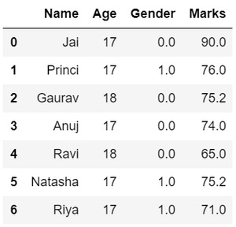

* **Filtering data**, suppose there is a requirement for the details regarding name, gender, marks of the top-scoring students. Here we need to remove some unwanted data.

|  |
| --- |
| Python3  # Filter top scoring students  df = df[df['Marks'] >= 75]  # Remove age row  df = df.drop(['Age'], axis=1)   # Display data  df |

**Output:**

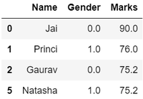

Hence, we have finally obtained an efficient dataset which can be further used for various purposes.

Now that we know the basics of data wrangling. Below we will discuss various operations using which we can perform data wrangling:

**Wrangling Data Using Merge Operation:**

Merge operation is used to merge raw data and into the desired format.

**Syntax:**

pd.merge( data_frame1,data_frame2, on="field ")

Here the field is the name of the column which is similar on both data-frame.

For example: Suppose that a Teacher has two types of Data, first type of Data consist of Details of Students and Second type of Data Consist of Pending Fees Status which is taken from Account Office. So The Teacher will use merge operation here in order to merge the data and provide it meaning. So that teacher will analyze it easily and it also reduces time and effort of Teacher from Manual Merging.

**FIRST TYPE OF DATA:**

|  |
| --- |
| Python3  # import module  import pandas as pd   # creating DataFrame for Student Details  details = pd.DataFrame({      'ID': [101, 102, 103, 104, 105, 106,             107, 108, 109, 110],      'NAME': ['Jagroop', 'Praveen', 'Harjot',               'Pooja', 'Rahul', 'Nikita',               'Saurabh', 'Ayush', 'Dolly', "Mohit"],      'BRANCH': ['CSE', 'CSE', 'CSE', 'CSE', 'CSE',                 'CSE', 'CSE', 'CSE', 'CSE', 'CSE']})    # printing details  print(details) |

**Output:**

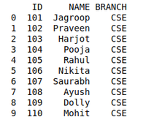

**SECOND TYPE OF DATA**

|  |
| --- |
| Python3  # Import module  import pandas as pd  # Creating Dataframe for Fees_Status  fees_status = pd.DataFrame(      {'ID': [101, 102, 103, 104, 105,              106, 107, 108, 109, 110],       'PENDING': ['5000', '250', 'NIL',                   '9000', '15000', 'NIL',                   '4500', '1800', '250', 'NIL']})  # Printing fees_status  print(fees_status) |

**Output:**

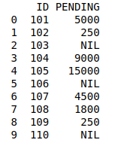

**WRANGLING DATA USING MERGE OPERATION:**

|  |
| --- |
| Python3  # Import module  import pandas as pd   # Creating Dataframe  details = pd.DataFrame({      'ID': [101, 102, 103, 104, 105,             106, 107, 108, 109, 110],      'NAME': ['Jagroop', 'Praveen', 'Harjot',               'Pooja', 'Rahul', 'Nikita',               'Saurabh', 'Ayush', 'Dolly', "Mohit"],      'BRANCH': ['CSE', 'CSE', 'CSE', 'CSE', 'CSE',                 'CSE', 'CSE', 'CSE', 'CSE', 'CSE']})   # Creating Dataframe  fees_status = pd.DataFrame(      {'ID': [101, 102, 103, 104, 105,              106, 107, 108, 109, 110],       'PENDING': ['5000', '250', 'NIL',                   '9000', '15000', 'NIL',                   '4500', '1800', '250', 'NIL']})  # Merging Dataframe  print(pd.merge(details, fees_status, on='ID')) |

**Output:**

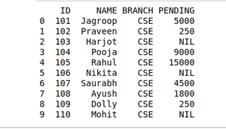

**Wrangling Data using Grouping Method**

The grouping method in Data analysis is used to provide results in terms of various groups taken out from Large Data. This method of pandas is used to group the outset of data from the large data set.

Example: There is a Car Selling company and this company have different Brands of various Car Manufacturing Company like Maruti, Toyota, Mahindra, Ford, etc. and have data where different cars are sold in different years. So the Company wants to wrangle only that data where cars are sold during the year 2010. For this problem, we use another Wrangling technique that is*groupby()*method.

**CARS SELLING DATA:**

|  |
| --- |
| Python3  # Import module  import pandas as pd  # Creating Data  car_selling_data = {'Brand': ['Maruti', 'Maruti', 'Maruti',                                'Maruti', 'Hyundai', 'Hyundai',                                'Toyota', 'Mahindra', 'Mahindra',                                'Ford', 'Toyota', 'Ford'],                      'Year':  [2010, 2011, 2009, 2013,                                2010, 2011, 2011, 2010,                                2013, 2010, 2010, 2011],                      'Sold': [6, 7, 9, 8, 3, 5,                               2, 8, 7, 2, 4, 2]}   # Creating Dataframe of car_selling_data  df = pd.DataFrame(car_selling_data)   # printing Dataframe  print(df) |

**Output:**

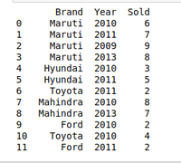

**DATA OF THE** **YEAR 2010:**

|  |
| --- |
| Python3  # Import module  import pandas as pd  # Creating Data  car_selling_data = {'Brand': ['Maruti', 'Maruti', 'Maruti',                                'Maruti', 'Hyundai', 'Hyundai',                                'Toyota', 'Mahindra', 'Mahindra',                                'Ford', 'Toyota', 'Ford'],                      'Year':  [2010, 2011, 2009, 2013,                                2010, 2011, 2011, 2010,                                2013, 2010, 2010, 2011],                      'Sold': [6, 7, 9, 8, 3, 5,                               2, 8, 7, 2, 4, 2]}   # Creating Dataframe for Provided Data  df = pd.DataFrame(car_selling_data)   # Group the data when year = 2010  grouped = df.groupby('Year')  print(grouped.get_group(2010)) |

**Output:**

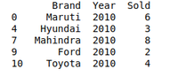

**Wrangling data by removing Duplication:**

Pandas *duplicates()* method helps us to remove duplicate values from Large Data. An important part of Data Wrangling is removing Duplicate values from the large data set.

**Syntax:**

DataFrame.duplicated(subset=None, keep='first')

Here subset is the column value where we want to remove Duplicate value.

In*keep*, we have 3 options :

* if  *keep =’first’* then the first value is marked as original rest all values if occur will be removed as it is considered as duplicate.
* if *keep=’last’* then the last value is marked as original rest all above same values will be removed as it is considered as duplicate values.
* if *keep =’false’* the all the values which occur more than once will be removed as all considered as a duplicate value.

For example, A University will organize the event. In order to participate Students have to fill their details in the online form so that they will contact them. It may be possible that a student will fill the form multiple time. It may cause difficulty for the event organizer if a single student will fill multiple entries. The Data that the organizers will get can be Easily Wrangles by removing duplicate values.

**DETAILS STUDENTS DATA WHO WANT TO PARTICIPATE IN THE EVENT:**

|  |
| --- |
| Python3  # Import module  import pandas as pd  # Initializing Data  student_data = {'Name': ['Amit', 'Praveen', 'Jagroop',                           'Rahul', 'Vishal', 'Suraj',                           'Rishab', 'Satyapal', 'Amit',                           'Rahul', 'Praveen', 'Amit'],                  'Roll_no': [23, 54, 29, 36, 59, 38,                              12, 45, 34, 36, 54, 23],                  'Email': ['xxxx@gmail.com', 'xxxxxx@gmail.com',                            'xxxxxx@gmail.com', 'xx@gmail.com',                            'xxxx@gmail.com', 'xxxxx@gmail.com',                            'xxxxx@gmail.com', 'xxxxx@gmail.com',                            'xxxxx@gmail.com', 'xxxxxx@gmail.com',                            'xxxxxxxxxx@gmail.com', 'xxxxxxxxxx@gmail.com']}   # Creating Dataframe of Data  df = pd.DataFrame(student_data)   # Printing Dataframe  print(df) |

**Output:**

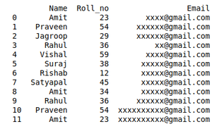

**DATA WRANGLED BY REMOVING DUPLICATE ENTRIES:**

|  |
| --- |
| Python3  # import module  import pandas as pd  # initializing Data  student_data = {'Name': ['Amit', 'Praveen', 'Jagroop',                           'Rahul', 'Vishal', 'Suraj',                           'Rishab', 'Satyapal', 'Amit',                           'Rahul', 'Praveen', 'Amit'],                  'Roll_no': [23, 54, 29, 36, 59, 38,                              12, 45, 34, 36, 54, 23],                  'Email': ['xxxx@gmail.com', 'xxxxxx@gmail.com',                            'xxxxxx@gmail.com', 'xx@gmail.com',                            'xxxx@gmail.com', 'xxxxx@gmail.com',                            'xxxxx@gmail.com', 'xxxxx@gmail.com',                            'xxxxx@gmail.com', 'xxxxxx@gmail.com',                            'xxxxxxxxxx@gmail.com', 'xxxxxxxxxx@gmail.com']}   # creating dataframe  df = pd.DataFrame(student_data)   # Here df.duplicated() list duplicate  Entries in ROllno.  # So that ~(NOT) is placed in order to get non duplicate values.  non_duplicate = df[~df.duplicated('Roll_no')]   # printing non-duplicate values  print(non_duplicate) |

**Output:**

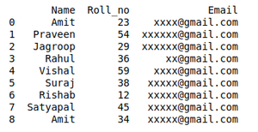

**Conclusion:** Hence we have thourouly studied how to perform the following operations using Python on any open source dataset (e.g., data.csv)

1. Import all the required Python Libraries.

2. Locate an open source data from the web (e.g., https://www.kaggle.com). Provide a clear description of the data and its source (i.e., URL of the web site).

3. Load the Dataset into pandas data frame.

4. Data Preprocessing: check for missing values in the data using pandas is null(), describe() function to get some initial statistics. Provide variable descriptions. Types of variables etc. Check the dimensions of the data frame.

5. Data Formatting and Data Normalization: Summarize the types of variables by checking the data types (i.e., character, numeric, integer, factor, and logical) of the variables in the data set. If variables are not in the correct data type, apply proper type conversions.

6. Turn categorical variables into quantitative variables in Python. In addition to the codes and outputs, explain every operation that you do in the above steps and explain everything that you do to import/read/scrape the data set.